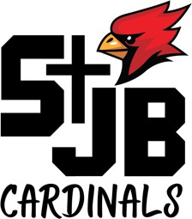
St. John The Baptist School 500 South 18th Street Plattsmouth, NE 68048

SCHOOL ADVISORY COUNCIL

FR. HOULIHAN
CHIEF ADMINISTRATIVE OFFICER

LINDA MONAHAN PRINCIPAL
"

DONNA WEEDA
Tuesday, February 18, 2020 6:30 PM – 8:00pm
School Library
Agenda

PRESIDENT

RICK SPICKA VICE PRESIDENT

SEAN GILLEN SECRETARY
TOM BECKMAN MELICCA CARPENTER MONICA YANKUS
- Call to Order and Opening Prayer
- Reading and Approval of Minutes from Last Meeting
- Strategic Plan
    - Update on Mission – Deb Walton
    - Update on Pillar feedback – Deb Walton
    - Communication to Parents
    - Pillar Leadership
- CAO Report
- Principle Report
  - Update on Enrollment
- New items
  - SAC board members and terms along with the impact of the strategic plan

- Adjournment and closing Prayer

