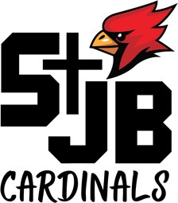
St. John The Baptist School 500 South 18th Street Plattsmouth, NE 68048

SCHOOL ADVISORY COUNCIL

FR. HOULIHAN
CHIEF ADMINISTRATIVE OFFICER

LINDA MONAHAN PRINCIPAL
"

DONNA WEEDA
Tuesday, December 17, 6:30 PM – 8:00pm
School Library
Agenda

PRESIDENT

RICK SPICKA VICE PRESIDENT

SEAN GILLEN SECRETARY
TOM BECKMAN MELICCA CARPENTER MONICA YANKUS
- Call to Order and Opening Prayer
- Reading and Approval of Minutes from Last Meeting
- Strategic Plan
    - Review of Pillars – Deb Walton
    - Review of Mission Statement – Deb Walton
- CAO Report
- Principle Report
  - Update on Tuition, Scholarships ect.
- New items
  - Parking during an event at the school
  - Electronic devices in church
  - Diocese communications regarding Scholastic Books, especially in light of the role of SAC as an advisory body.
  - Website Traffic

- Adjournment and closing Prayer

