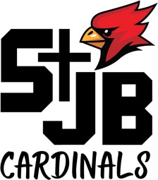
St. John The Baptist School 500 South 18th Street Plattsmouth, NE 68048

SCHOOL ADVISORY COUNCIL

FR. HOULIHAN
CHIEF ADMINISTRATIVE OFFICER

LINDA MONAHAN PRINCIPAL
"

DONNA WEEDA
Tuesday, October, 8 7:00 PM
School Library
Agenda

PRESIDENT

RICK SPICKA VICE PRESIDENT

SEAN GILLEN SECRETARY
TOM BECKMAN MELICCA CARPENTER MONICA YANKUS
- Call to Order and Opening Prayer
- Reading and Approval of Minutes from Last Meeting
- Chief Administrative Officer’s Report
- Principal Report
  - Financial Update for next year
    - If we are not receiving the $160k does the budget show we are ok?
    - Minimum amount we need to hit for Spring Dinner?
    - Tuition for 20-21 school year
  - Update on Lunch Program
    - Ice maker, salad bar
  - Update athletic program for winter
    - Any issues with the numbers?
  - Scholarships for non-parishioners
  - Other topics?
- Open questions on Parent Satisfaction?
- Open questions on tithing?
- SWOT Analysis – Deb Walton
  - Discussion and sharing of proposed SP Pillars/ Buckets and the goal or vision for each.
  - Finalize Pillars
  - Identify potential new pillar leads based on strengths and skills
  - Determine Communication plan for asking new leads (and next steps) and discuss Transitional communication from current Pillar Leads to new
  - Review proposed mission statement and finalize for approval
  - Discuss communication plan - how do we communicate the refreshed Mission and does this change /affect marketing communications

Proposed Mission Statement

We, St. John the Baptist School, will educate each student by embracing our faith and upholding academic excellence within a Catholic community devoted to developing the whole child.

- Adjournment and Closing Prayer

