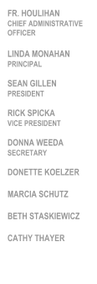
REGULAR MEETING

Tuesday, June 11,2019
7:00 PM
School Library

AGENDA

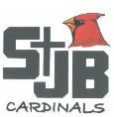
St. John the Baptist School
500 South 18th Street Plattsmouth, NE 68048

School Advisory Council
- Call to Order and Opening Prayer
- Reading and Approval of Minutes from Last Meeting
- Chief Administrative Officer’s Report
- Principal’s Report
  - Enrollment numbers
  - Staffing
- Parish Council
- Old Business
  - SWOT Analysis
    - Review Process and Objective
    - Set Date and Time for SWOT meeting
- New Business
- Adjournment and Closing Prayer

